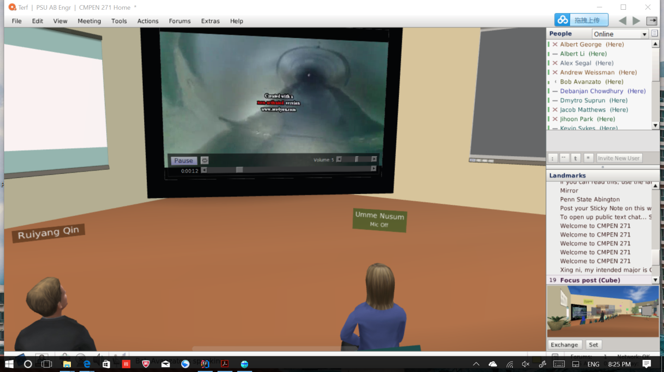

This lecture makes me realized a very interesting thing about the Pipe robot. Because the path inside of pipe is not like the normal path, it has curve. In this way, the wheel of the Pipe robot must be designed specially. I also read some papers for this pipe robot. One thing I am considering is that it may be shrink into nanometer scale so that it will be able to enter human’s vein to fix some illness.